**2025 Spring Bike Fling**

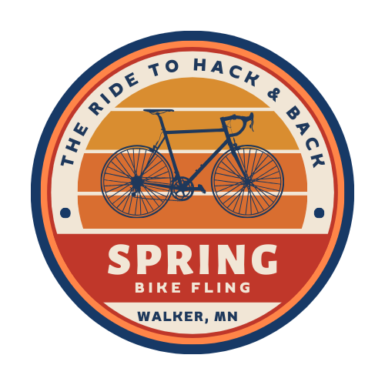

Saturday June 21nd, 2025

Start Walker City Park at 10:00am

Choose either the straight 12-mile ride or the Walker Loop

Meet in Hackensack at Rendezvous Brewery

Return to Portage Brewery for Music

Choose either the straight 12-mile ride or the Walker Loop

Register at: bikereg.com

**“Hack and Back”**

