2024 Spring Bike Fling
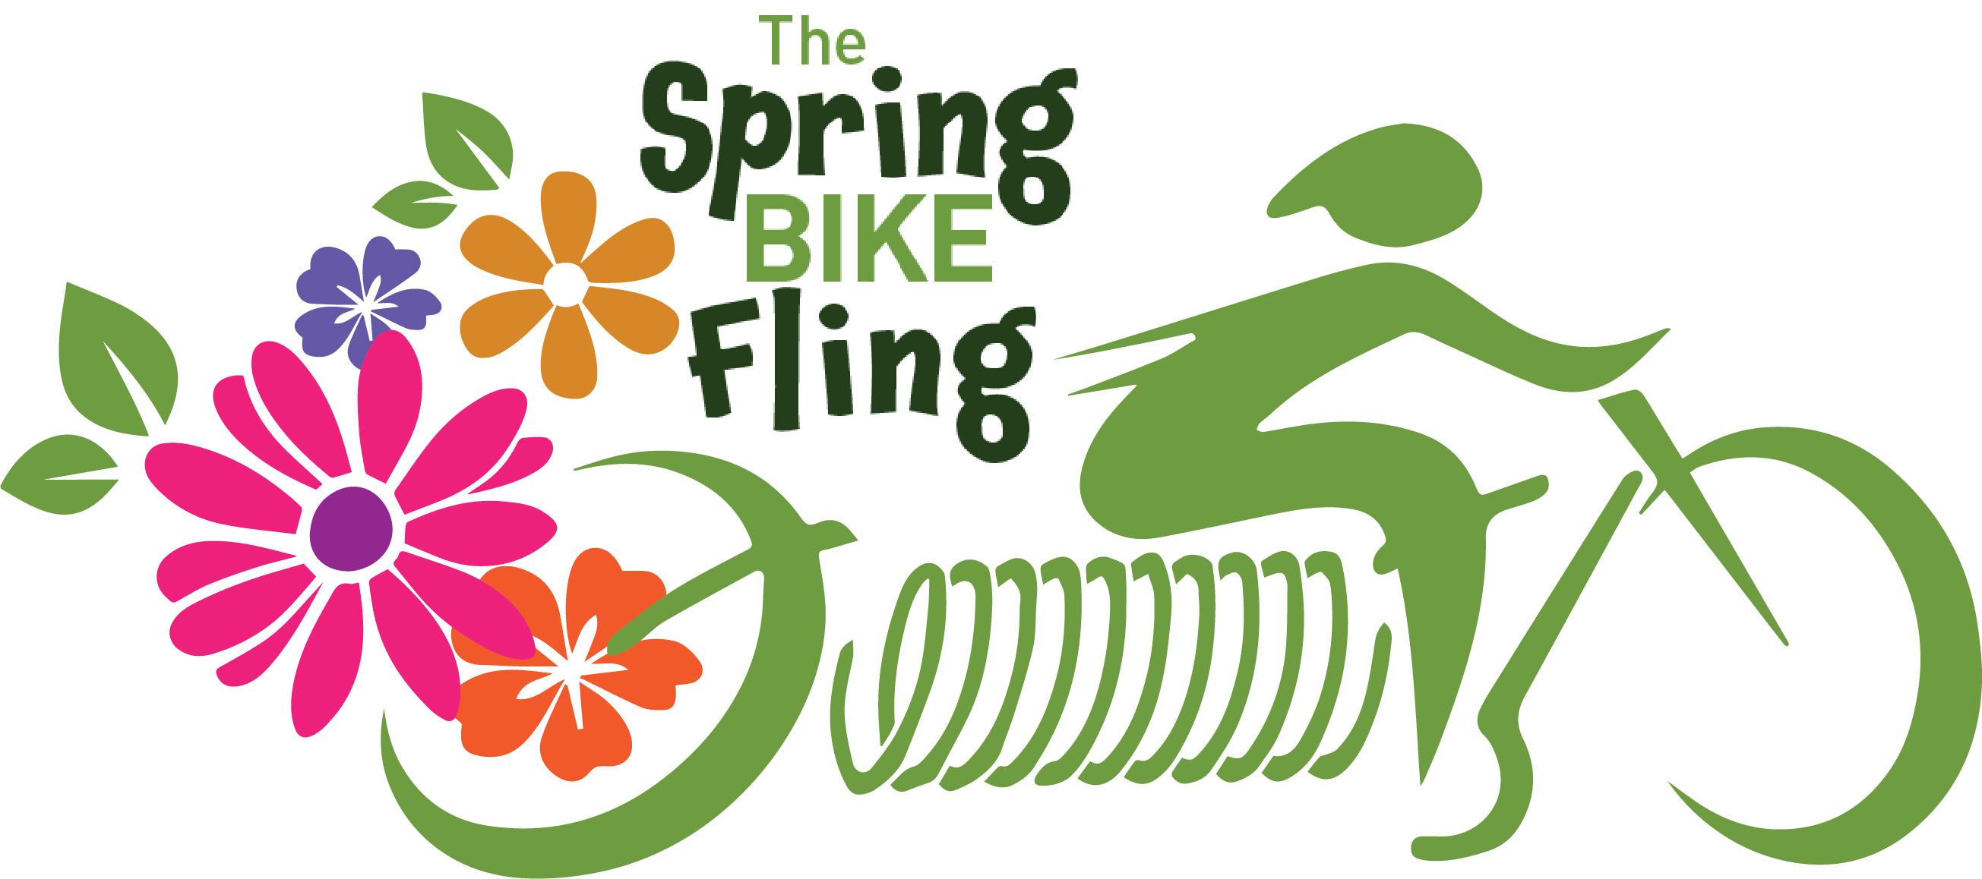
Saturday June 22nd, 2024
Start Walker City Park at 10:00am
Choose either the straight 12-mile ride or the Walker Loop
Meet in Hackensack at Rendezvous Brewery
Return to Portage Brewery for Music
Choose either the straight 12-mile ride or the Walker Loop
Register at: bikereg.com
“Hack and Back”
