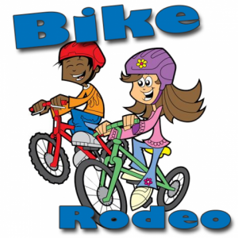

What is a Rodeo
A Bike Rodeo is usually a bicycle safety clinic featuring bike safety inspections (and optionally quick tune-ups), A ride on a miniature "chalk street" course set up in a parking lot where young cyclists are shown where and how to apply the rules.
^{Bring your own Bike and helmet}
May 18th, 2019 Walker City Parks
10:30 am Family and Kid Ride – This is a great opportunity to get riding with your family and friends. 3 Mile ride led by Paul, the bike guy.
11:30 am – Bike Rodeo in Walker City Park.
The main focus of a bike rodeo is Cycling Safety for young cyclists, ages kindergarten to 14 or so.
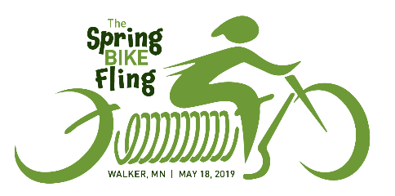
The kid friendly event above is happening in conjunction with The Spring Bike Fling – A 22- or 44-Mile ride on the beautiful trails in the Walker Area.
Registration begins at 9:00 am. For more information call the chamber at 218-547-1313 or find registration information at leech-lake.com

