2022 Spring Bike Fling
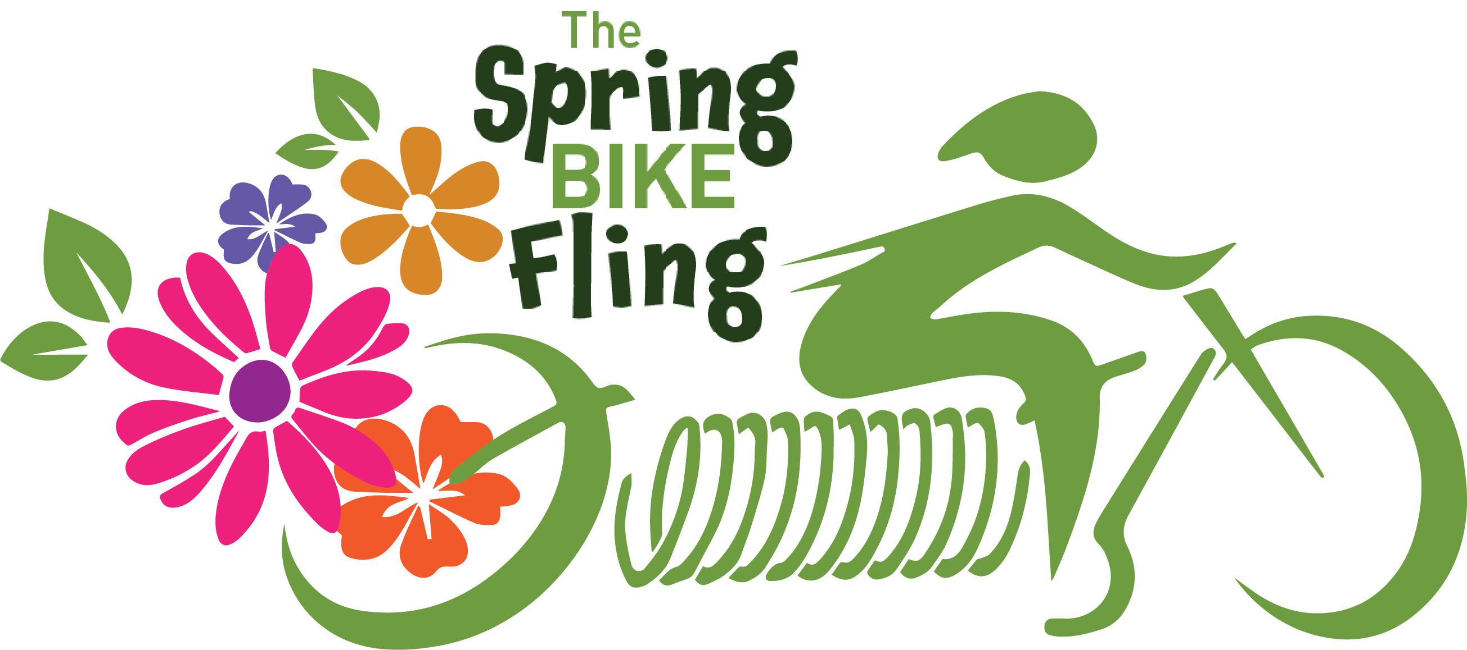
Saturday June 25th 2022
Start Walker City Park at 10:00am
Choose either the straight 12 mile ride or the Walker Loop
Meet in Hackensack at Rendezvous Brewery
Return to Portage Brewery for Music
Choose either the straight 12 mile ride or the Walker Loop
Register at: bikereg.com
“Hack and Back”
