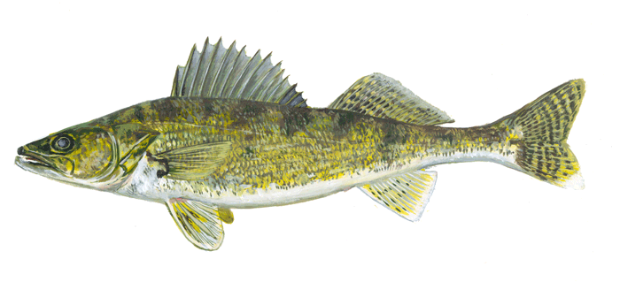
SUMMER NATURALIST PROGRAMS
Chippewa National Forest 2016
Cut Foot Sioux and Norway Beach Visitor Centers

Date/Time | Title | Location
June 8,  10 a.m. | Hummingbirds in my Ears! | Cut Foot Sioux
June 11,  10 a.m. | National Get Outdoors Day  Tent Races and other  Camp Games | Norway Beach
June 15  10:a.m. | Black Bears of Minnesota | Cut Foot
June 18  10 a.m. | Wildflowers | Norway Beach
June 22  10: a.m. | Let’s Catch Water Critters | Cut Foot
June 25  10 a.m. | Minnesota’s State Flower—Showy Ladyslipper | Norway Beach
June 29  10 a.m. | Porcupines—Not So Prickly | Cut Foot
July 2  10 a.m. | Orchid Car Caravan  Follow Us for a Short Drive Along the Ladyslipper Scenic Byway | Norway Beach
July 4  9-11:00 | Bike Parade  Decorate your bikes anytime from 9:00-10:00 a.m., parade begins at 10:00. Bike from VIC to Wanaki and back. | Norway Beach
Naturalist hikes are also scheduled every Wednesday at 1:00 at Cut Foot Sioux and every Saturday at 1:00 at Norway Beach.
For more information, contact the Chippewa National Forest Supervisor’s Office at 218-335-8600 or follow us on Twitter or Facebook at #ChippewaNF.
SUMMER NATURALIST PROGRAMS
Chippewa National Forest 2016
Cut Foot Sioux and Norway Beach Visitor Centers
July 6  10 a.m. | A flutter of butterflies….  Learn to identify Forest butterflies! | Cut Foot
July 9  10 a.m. | Get to Know  Minnesota’s Bats | Norway Beach
July 13  10 a.m. | Get to Know  Minnesota’s Bats | Cut Foot
July 16  10 a.m. | Fish Prints  Bring along an old tshirt or you can purchase one at the Visitor Center (while supplies last) | Norway Beach
July 20  10 a.m. | Fish Prints  Bring along an old tshirt or you can purchase one at the Visitor Center (while supplies last) | Cut Foot
July 23  10 a.m. | Bald Eagles | Norway Beach
July 27  10 a.m. | Bald Eagles | Cut Foot
July 30  10 a.m. | Minnesota’s State Bird--Loons | Norway Beach
August 3  10 a.m. | Smokey’s Birthday  Join us for Birthday Cake and firefighter games! | Cut Foot

Naturalist hikes are also scheduled every Wednesday at 1:00 at Cut Foot Sioux and every Saturday at 1:00 at Norway Beach.
For more information, contact the Chippewa National Forest Supervisor’s Office at 218-335-8600 or follow us on Twitter or Facebook at #ChippewaNF.

SUMMER NATURALIST PROGRAMS
Chippewa National Forest 2016
Cut Foot Sioux and Norway Beach Visitor Centers

August 6  1 p.m. | Smokey’s Birthday  Join us for Birthday Cake and firefighter games! | Norway Beach
August 11  10 a.m. | Name that Frog Song | Cut Foot
August 13  10 a.m. | Name that Frog Song | Norway Beach
August 17  10 a.m. | Breakfast in Ojibwe | Cut Foot
August 20  10 a.m. | Breakfast in Ojibwe | Norway Beach

Naturalist hikes are also scheduled every Wednesday at 1:00 at Cut Foot Sioux and every Saturday at 1:00 at Norway Beach.
For more information, contact the Chippewa National Forest Supervisor’s Office at 218-335-8600 or follow us on Twitter or Facebook at #ChippewaNF.

Locations
- Cut Foot Sioux Visitor Center is located 17 miles northwest of Deer River, MN off Highway 46.
- Norway Beach Visitor Center is located 5 miles east of Cass Lake, MN off Highway 2.

