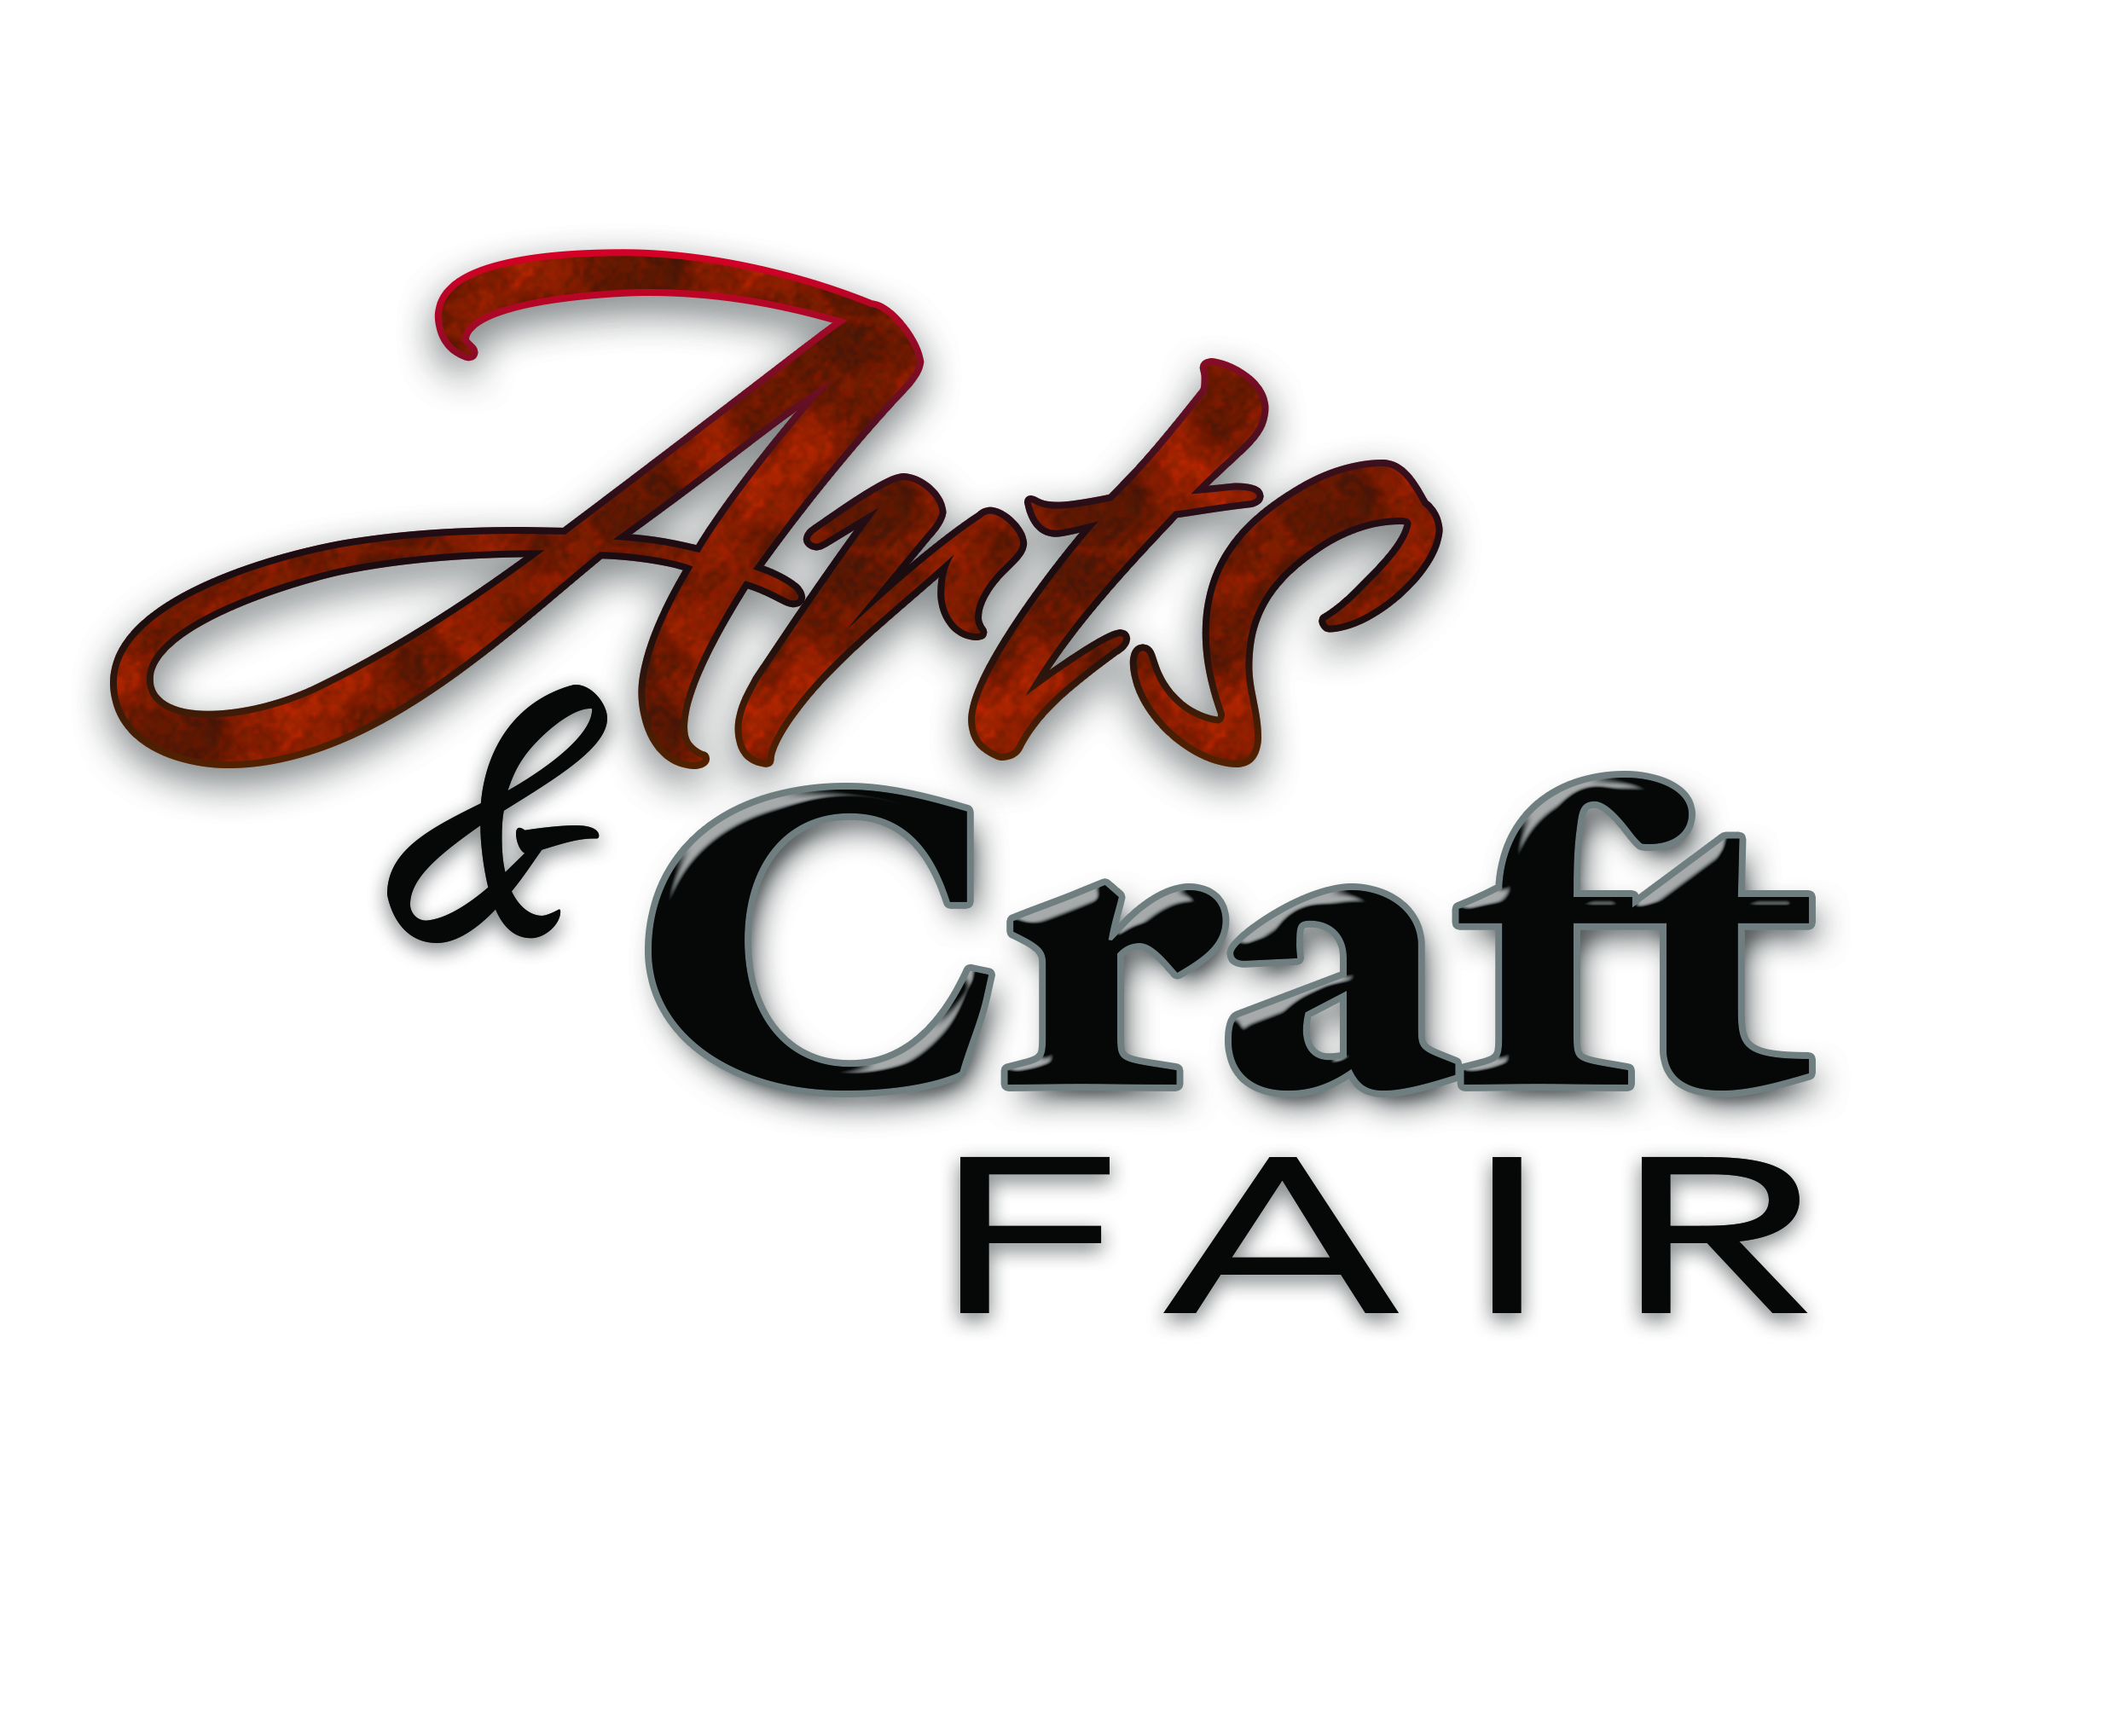

Greetings,

We are excited to announce a new Walker Area Arts and Craft Fair. It is sponsored by Leech Lake Area Chamber of Commerce and Northern Lights Casino, Hotel and Events Center.
The fair will be held on Saturday November 21, 2015 from 10:00 am to 5:00 pm
at the Northern Lights Event Center.

This inaugural show (always to be held 2nd weekend of deer hunting) will provide an opportunity for local and regional artists/crafters to offer their work and products just in time for the holiday season.

Please read through the applications carefully to ensure you are following all of the correct processes.

All work must be original. Commercially produced articles not allowed for resale. Please don’t hesitate to call us if you have any questions about this.

Please fill out and include proof of insurance/insurance waiver and Operator Certificate of Compliance form when returning application and payment.

Sincerely,

Cindy Wannarka
President/CEO
Leech Lake Area Chamber of Commerce
800-833-1118
cindy@leech-lake.com

